Requirement Gathering and Analysis Phase

Date: 15/04/2025

Team ID: SWTID1742901502

Project Name: Nexus: Social Media App (MERN)

Maximum Marks: —

# Data Flow Diagram (DFD)

A Data Flow Diagram (DFD) is a visual representation of the flow of information within a system. **Key Components of the DFD:**

1. **External Entities**:
   * **Users**: The individuals who interact with the app to create and consume content.
   * **Third-party APIs**: Services for features like content hosting, analytics, or social sharing (optional integration).
2. **Processes**:
   * **User Registration and Login**: Handles user authentication and onboarding (e.g., JWT-based login, bcrypt for password hashing).
   * **Content Creation and Sharing**: Facilitates the creation, editing, and publishing of posts or media.
   * **User Interaction**: Processes likes, comments, and real-time engagement actions.
   * **Trending Content Discovery**: Identifies and displays trending posts and profiles based on engagement metrics.
   * **User Profile Management**: Handles user settings, bio updates, and personal data management.
   * **Security Mechanisms**: Manages session validation and secure data storage.
3. **Data Stores**:
   * **User Database**: Stores user account information, authentication tokens, and hashed passwords.
   * **Content Database**: Houses user posts, comments, and media files.
   * **Activity Log Database**: Tracks user interactions such as likes, comments, and shares.
   * **Trending Metrics Store**: Maintains data required for identifying trending content (e.g., number of views, engagement rates).
4. **Data Flows**:
   * User input data (registration details, posts, comments) flowing into the system.
   * Processed data (trending content, personalized recommendations) flowing back to the user interface.
   * Secure transmission of authentication tokens and credentials.
5. **User Interface (UI)**:
   * Visually engaging and responsive design layers for interaction.

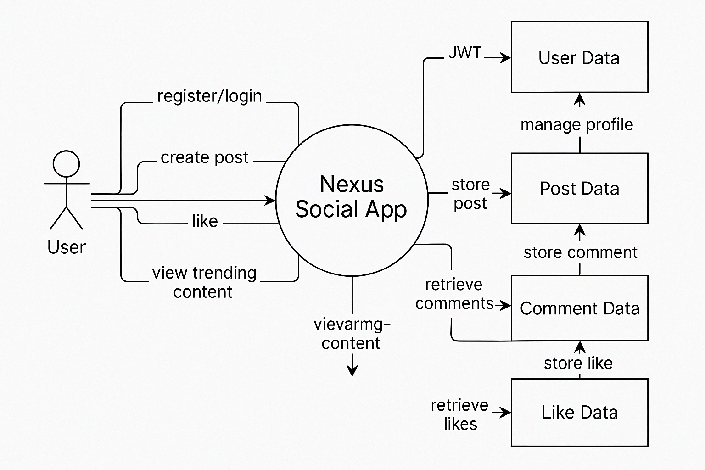

# User Stories

| **User Type** | **Functional Requirement (Epic)** | **User Story Number** | **User Story / Task** | **Acceptance Criteria** | **Priority / Release** |
| --- | --- | --- | --- | --- | --- |
| **User** | Registration | USN-1 | As a user, I can register with an email and password. | I can log in and access the dashboard. | High / Sprint-1 |
| **User** | Email Confirmation | USN-2 | As a user, I will receive a confirmation email after registering. | I receive and confirm via email. | High / Sprint-1 |
| **User** | Social Media Sign-Up | USN-3 | As a user, I can register using my Google account. | I can sign up using Gmail. | Medium / Sprint-1 |
| **User** | Login | USN-4 | As a user, I can log in using my credentials. | I’m redirected to my dashboard. | High / Sprint-1 |
| **User** | Content Creation | USN-5 | As a user, I can create and share posts with text and images. | My posts are visible on my profile and timeline. | High / Sprint-2 |
| **User** | Real-Time Interaction | USN-6 | As a user, I can like and comment on posts. | My interactions are immediately reflected. | High / Sprint-2 |
| **User** | Trending Discovery | USN-7 | As a user, I can explore trending posts and profiles. | Trending content is displayed on the explore page. | Medium / Sprint-3 |
| **User** | Account Management | USN-8 | As a user, I can update my profile and change my settings. | Profile changes are reflected on my profile. | Medium / Sprint-2 |
| **Admin** | User Monitoring | USN-9 | As an admin, I can monitor user activity and generate reports. | Detailed user activity logs are available. | Medium / Sprint-3 |
| **Admin** | Content Moderation | USN-10 | As an admin, I can remove or flag inappropriate content. | Content flagged or removed appears on admin logs. | High / Sprint-3 |